Basic Electrostatics System
Objective:
To examine the difference between charging by induction and charging by contact and how charge is distributed on different conductive shapes, and to demonstrate the conservation of charge.
Equipment:
Electrometer, Faraday Ice Pail, Charge Producers, Signal Input Cable (test leads), Earth ground connection, Electrostatic Voltage Source, Proof Plane, and Conductive Spheres of different shapes.
Theory:
If you try to comb your hair with a rubber comb on a dry day, the hair crackles and the its ends get attracted to the comb. If this is done in a dark room in front of a mirror, you can see tiny sparks that jump between the comb and your hair. This intriguing phenomenon that we all experience is due to to a physical property of matter called the electric charge. The SI unit of electric charge is coulomb (C).
Electric charges are either negative or positive. A body with an excess number of electrons is said to be negatively charged, otherwise it will be positively charged. And it is uncharged or neutral if its positive and negative charges balance each other. Like charges repel each other, unlike charges attract each other.
In this experiment, we will learn how to charge an object by contact as compared to charging it by induction, and to demonstrate the conservation of charge.
Also we will examine the way charge is distributed over a surface by measuring variations of charge density. A charged surface will be sampled with a proof plane. The proof plane will then be inserted in the Faraday Ice Pail to measure the charge.
By sampling different sections of the surface, the relative charge density can be observed. And we will distinguish between uniform and non-uniform charge distribution.
An important aspect of measuring charge distributions is charge conservation. The proof plane removes some charge from the surface it samples. If the proof plane is grounded after each measurement, the surface will be depleted of charge with consecutive measurements.
However, by not grounding the proof plane (and by not letting it touch the ice pail), the charge on the surface is not depleted. That charge which the proof plane removed for one measurement is always returned to the surface when the next sampling is made.
Demonstration 1: Faraday Ice Pail and Charge Production
Procedure:
Before beginning any experiment using the ice pail, the pail must be momentarily grounded. When the ice pail is connected to the electrometer, and the electrometer is connected to an earth-ground, simply press the ZERO button whenever you need to discharge both the pail and the electrometer. While conducting an experiment, it is convenient to keep yourself grounded, by continuously resting one hand on the upper edge of the shield, or by direct contact with the earth-ground connector.
WARNING: Make sure the electrometer is connected to an earth ground, or the pail will not be properly grounded. Performing tests or experiments with an ungrounded pail could cause possible electrical shock or injury.
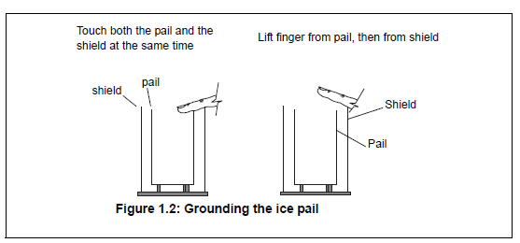
Procedure 1A: Charging by Induction vs. Charging by Contact
1. Connect the electrometer to the Faraday Ice Pail as shown in Figure 1.1. Make sure to ground the electrometer and the ice pail. The electrometer should read zero when grounded, indicating there is no charge in the ice pail. Press the ZERO button to completely remove all charge from the electrometer and the ice pail.
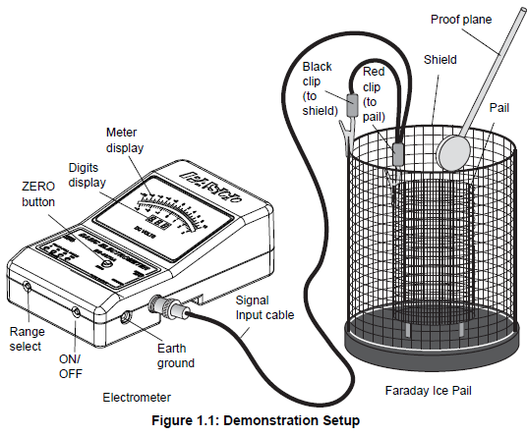

2. Always start with the voltage range in the higher setting (100 V) and adjust down if needed. Analog meters are typically most accurate in the range of 1/3 to 2/3 of full scale.
3. The charge producers will be used as charged objects. Here is a general procedure to follow when charging the producers:
• Always remove any stray charge on the necks and handles of the charge producers by touching the necks and handles to the grounded shield. You must also be grounded while doing this. It also helps if you breathe on the neck of the charge producer, so that the moisture in your breath removes any residual charge on the neck.
• Rub the white and blue surfaces together to separate charges.
• Keep in your hand only the producer you are going to use. Put the other charge producer away, far from contact with any of the ice pail surfaces.
• Before inserting the charged disk in the ice pail, make sure you’re touching the grounded shield.
4. Carefully insert the charged object into the ice pail, all the way to the lower half of the pail, but without letting it touch the pail. Record the electrometer reading.
5. Remove the object and again Record the electrometer reading.
6. Push the ZERO button to remove any residual charge. Now insert the object again, but let it touch the ice pail.
7. Remove the object and note the electrometer reading.
Procedure 1B: Conservation of Charge
1. Starting with initially uncharged charge producers, rub the blue and white materials together.
Follow the general procedure for charging listed in part 1A, except that in this case you must keep both producers from touching anything else after charging. (Keep them in your hands, without letting them touch each other or the ice pail.)
2. Use the Faraday Ice Pail to measure the magnitude and polarity of each of the charge producers by inserting them one at a time into the ice pail and noting the reading on the electrometer.
3. Completely remove all charge from the charge producers by grounding them. Do not forget to also remove any stray charge from the necks and handles.
4. Insert both charge producers into the ice pail and rub them together inside the pail. Record the electrometer reading. Do not let the charge producers touch the pail.
5. Remove one charge producer and note the electrometer reading. Replace the charge producer and remove the other. Record the electrometer readings. Comment on conservation of charge.
Demonstration 2: Charge Distribution
Procedure:
NOTE: When the disk of the proof plane touches the surface being sampled, it essentially becomes part of the surface. To minimize distortion of the surface shape when sampling, hold the proof plane flat against the surface, as indicated in the accessory instructions. Please refer to the accessory instructions for details on how to use the proof planes.

1. Before starting, make sure the Faraday Ice Pail is properly grounded, with the shield connected to earth ground. The electrometer, connected to the pail, must also be grounded (for example, when connected to the COM port on the electrostatics voltage source). Follow the setup in Figure 2.1, with the black lead connected over the edge of the shield and the red lead connected over the edge of the ice pail.
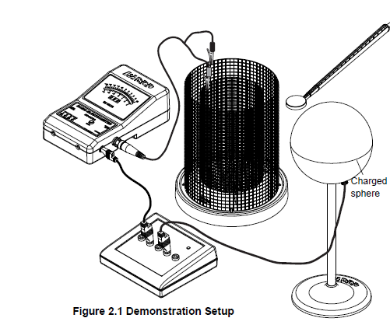
2. Place the two conductive spheres at least 50 cm apart. Connect one of the spheres to the +2000 VDC port on the Electrostatic Voltage Source. The voltage source should be grounded to the same earth ground as the shield and the electrometer. (An earth ground for the system is the AC adapter power supply for the Electrostatic Voltage Source.) The connected sphere will be used as a charged body.
3. Start the demonstration by sampling and recording the charge at several different diametrically opposite points on the charged sphere to represent an overall sample of the surface. Record and comment on your findings.
4. Momentarily ground the other sphere S2 to remove any residual charge from it.
5. Now bring the +2000 VDC charged sphere close to the grounded sphere, until their surfaces are about 1 cm apart. Then sample and record the charge on the opposite sides of sphere S2.
6. Momentarily ground S2 again, by touching one hand to the grounded ice pail shield and the other hand to the sphere. (Make sure the ice pail is grounded before doing this.) Again, sample and record the charge at the same points sampled before.
Conductive Conical Shape
1. Remove the two conducting spheres. Connect the conductive conical shape to the +2000 VDC port on the ElectrostaticsVoltage Source.
2. Use the proof plane to sample and record the charge at the larger rounded end and then at the narrow end.

Conductive Hollow Sphere
1. Remove the conducting conical shape. Connect the conductive hollow sphere to the +2000 VDC port on the Electrostatics Voltage Source.
2. Use the proof plane to sample the charge on the outside surface of the sphere. Then use the conductive knob end of the proof plane to sample the charge inside the sphere. Record and comment on your findings.
(Be sure to eliminate stray charges from necks and handles, to prevent erroneous readings.)

Physics 201L
Basic Electrostatics System

Charging by Induction (1.5 pts)
- Record the electrometer reading after inserting the charged object into the ice pail, all the way to the lower half of the pail, but without letting it touch the pail.
7V
- Record the electrometer reading after removing the object.
0V

- Why was there a potential difference between the pail and the shield only while the charged object was inside.
Student of fortune answer goes here
Charging by contact (1.5 pts)
- Insert the object again, but let it touch the ice pail. Remove the object and record the electrometer reading.
7V
- Why is there now a permanent potential difference between the ice pail and the shield? Where did the charge on the ice pail come from?
Student of fortune answer goes here
- Ground the ice pail to remove all charge. Press the ZERO button to remove residual charges from the electrometer. Insert the charge producer again into the ice pail. Does any charge remain on it? Where was it lost?
Student of fortune answer goes here

Conservation of Charge (1.5 pts)
- Magnitude and polarity of each of the charge producers inserted one at a time:
Qblue = 6V
Qwhite =-6V

Comment on your result. Student of fortune answer goes here

- After inserting both charge producers into the ice pail, rub them together inside the pail. Record the electrometer reading. (Do not let the charge producers touch the pail)
QTotal = 0V

- Replace the charge producer and remove the other. Record the electrometer readings.
Qblue = 4V
Qwhite = -4V
Explain your results. Student of fortune answer goes here

Charge distribution:
A-Conductive Spheres: (3 pts)
Charged Sphere | Sampling Sphere  (50 cm apart) | Sampling Sphere  (1 cm apart)
QA = 5V  QB = 5V  QC = 5V  QD = 5V | QA = 0V  QB = 0V  QC = 0V  QD = 0V | QA = 6V  QB = -5V  QC = -6V  QD = 5V

What produced the charge distributions at each step of the experiment? Draw a sketch of the distribution of charge on both spheres at every stage. Student of fortune answer goes here
B-Conductive Shapes:(2.5 pts)

Conductive Conical Shape | Conductive Hollow Sphere
QLarge rounded end = 4V  QSmall rounded end = 10V | Qoutside = 5V  Qinside = 0V

Explain the differences in charge density in each case. You can use sketches to develop your description. Student of fortune answer goes here

